INTRODUCTION

In the modern world dominated by information technology, such communication channels as television, radio, newspapers and magazines are becoming outdated and outrun in popularity by the internet media. Now, besides the ordinary content marketing performed via long and short videos on social media platforms, the new trend of live streaming has become a rapidly growing industry and is estimated to be worth $60 billion annually.

PURPOSES OF THE RESEARCH

This research has been conducted to fulfill mainly two purposes:

1. Indicate what factors of live streaming platforms influence consumer buying behavior
2. Identify the audiences that are most susceptible to marketing through such medium

SIGNIFICANCE

When this information is available it can assist both local and foreign businesses that are trying to penetrate the Chinese market, to choose the most suitable marketing strategy for their product. The insights received from this investigation can also be used to support further academic research in the field of international online marketing.

INTRODUCTION OF TAOBAO LIVE

Alibaba’s Taobao Live has been specifically chosen for this paper as the most outstanding example of a live streaming platform. With the most significant market share of 80%, Alibaba’s Taobao Live remains the leader among the other large live streaming platforms.

HYPOTHESES SUMMARY

In order to fulfil the first goal of this research, we are going to test the following hypotheses.

H1. Taobao Live influences buying behavior because its environment allows users to familiarize with the products in more detail.

H1a: Taobao live provides detailed information on products in general

H1b: Taobao Live provides detailed information on products use and features

H1c: Taobao Live provides detailed information on products quality

H1d: Taobao Live provides detailed information on products appearance

H2. Taobao Live successfully handles dissonance reducing buying behavior by drawing user's attention to the products, therefore providing bigger visibility and perceived availability for consumers.

H3. Taobao Live is influencing buying behavior, because it provides a highly interactive platform both among users and between users and businesses.

H4. Taobao Live influences buying behavior because it provides a platform, where consumers can be highly engaged with the brands, and form brand loyalty.

HYPOTHESIS 1

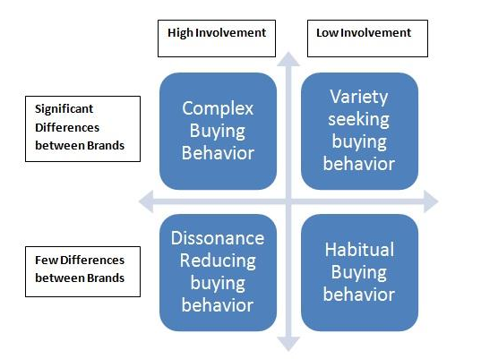

Generally, there are four types of buying behavior identified in marketing.

The two types of buying behavior with high involvement is complex and dissonance reducing buying behavior.

The complex buying behavior typically occurs when the consumer contemplates an expensive purchase. Since the purchase implies more financial risk, the consumer will be prone to do a thorough research before the commitment to invest.

It is logical to suppose that this kind of behavior can be well handled by the live steam marketing. Live streaming environment allows for a very natural way of educating the buyer about the product in great detail and helping them form beliefs and attitudes towards the product more easily

From the aforementioned statements, the following hypothesis was derived:

H1. Taobao Live influences buying behavior because its environment allows users to familiarize with the products in more detail.

Which breaks down to:

H1a: Taobao live provides detailed information on products in general

H1b: Taobao Live provides detailed information on products use and features

H1c: Taobao Live provides detailed information on products quality

H1d: Taobao Live provides detailed information on products appearance

HYPOTHESIS 2

The second type of buying behavior is dissonance reducing buying behavior. This kind of behavior is usually involved when the difference between brands is low, the price is high and the purchase is not frequent. In this case the consumer will buy the product that is more easily available and has more exposure.

Since most live streamers already have big following in social media, more people’s attention will be drawn towards the advertised products.

From here, our second hypothesis can be derived:

H2. Taobao Live successfully handles dissonance reducing buying behavior via providing bigger visibility to the products.

HYPOTHESIS 3

According to Kotler & Armstrong (2010) a consumer’s buying behavior is generally influenced by three major factors, which include social, personal and psychological factors. Concerning the social factors, they identified three types of groups that influence an individual’s decisions: membership groups (the one an individual is a part of), reference groups (people whom an individual interacts with on a regular basis and who provide comparison opportunity to consumers regarding their habits, lifestyle and behavior), and finally aspirational groups (the groups that the consumer wants to be a member of in the future)

If an individual is a follower of one or more key opinion leaders on social media and aspires to be like them in one way or another, they can be called his/her aspirational group. The people this individual interacts with on social media can be seen as his/her reference group.

From here we derive our third hypothesis:

H3. Taobao Live is influencing buying behavior, because it provides a highly interactive platform both among users and between users and businesses.

HYPOTHESIS 4

The two works referenced in this book by Mollen & Wilson (2010) and by Shang (2006) suggest that there is a strong connection between online consumer engagement and buying behavior.

The work of Shang proved that user engagement in the virtual community of Apple Software increased their knowledge of the brand and consequently increased brand loyalty.

From there we derive our final hypothesis about Taobao Live:

H4. Taobao Live influences buying behavior because it provides a platform, where consumers can be highly engaged with the brands and form brand loyalty.

METHODOLOGY

The research has been carried out in two steps:

1. A 14 question survey on Taobao Live use and features has been conducted on wenjuan.com and disseminated via advertisement in social media as well as on surveymonkey.com, a website that connects researchers with people ready to take surveys.
2. The collected answers then have been analyzed using statistical software in order to extract trends and confirm or dismiss the hypotheses. The analysis has been conducted by building a linear regression model from the data.

SURVEY RESULTS

The survey has collected 501 responses within thirty days. The results are as following:

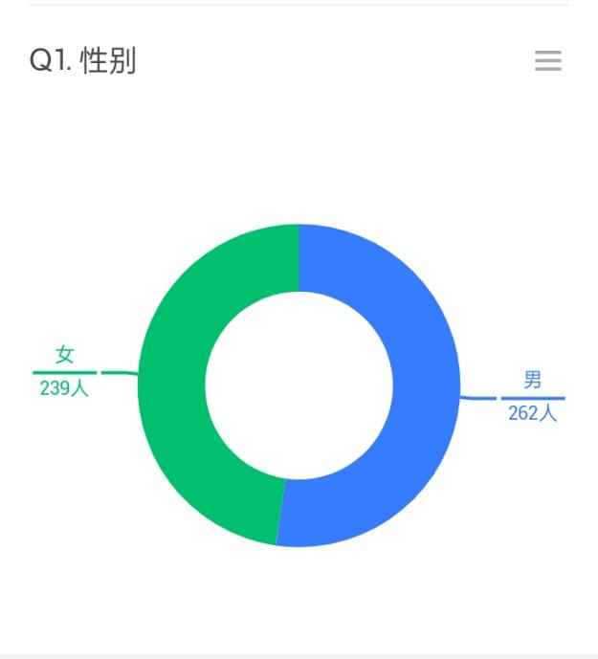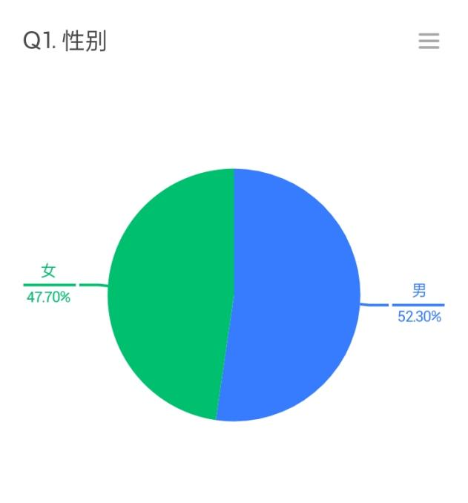

Figure 4. Question 1

Slightly more than a half of the respondents are male.

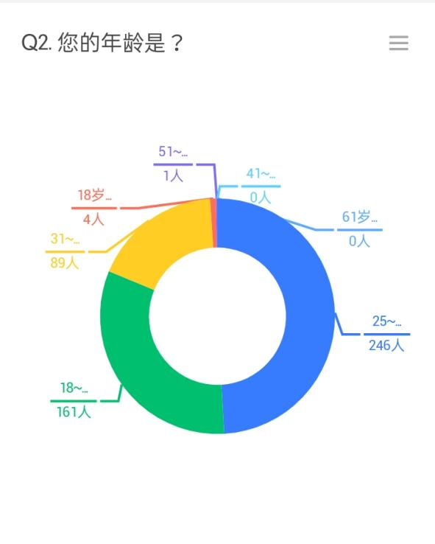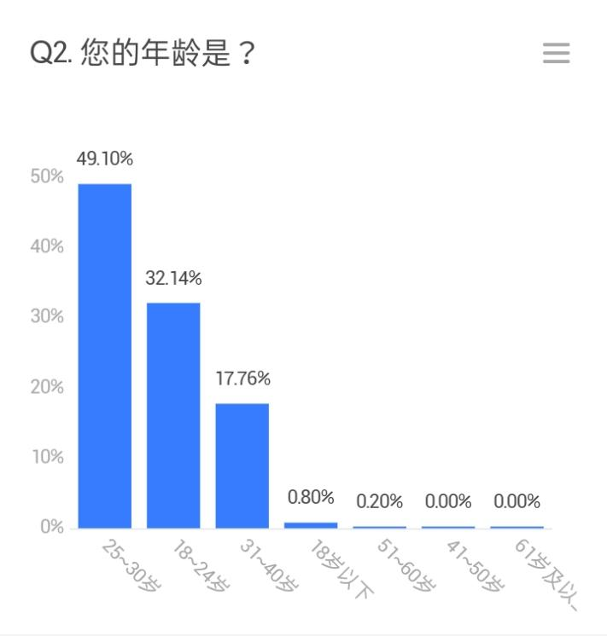

Figure 5. Question 2

The most significant age groups being between 25-30 (49%), 18-24 (32%) and 31-40 (17%), while only 4 people were under 18 and one person 51-60.

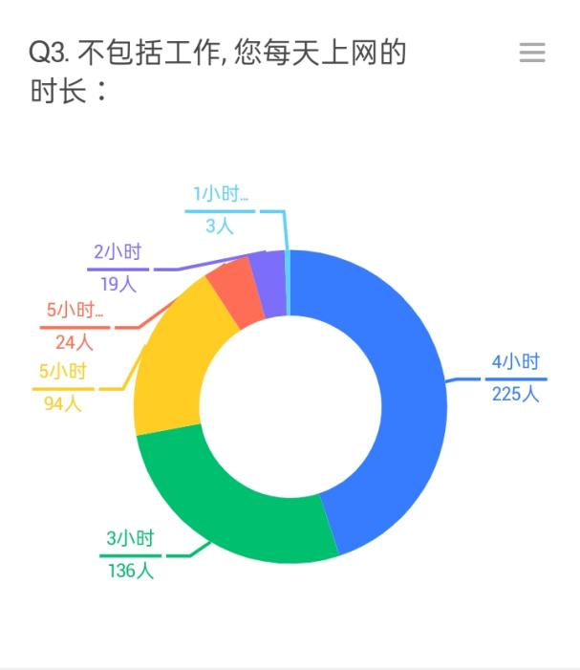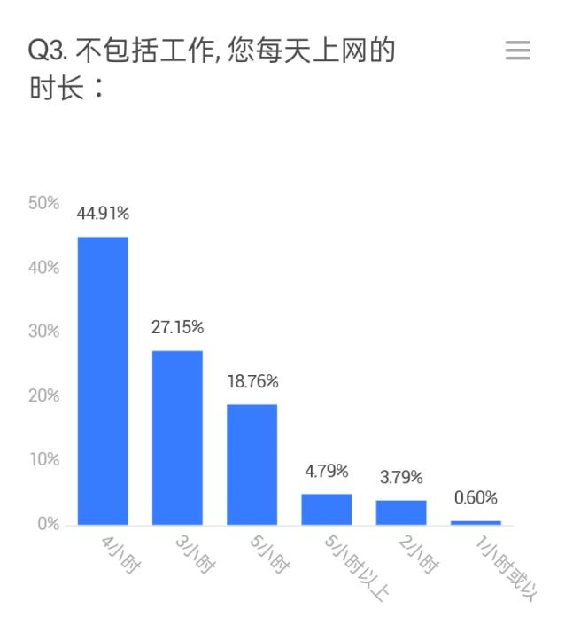

Figure 6. Question 3

Most of the respondents reported spending 4 hours (44%), 3 hours (27%) or 5 hours (18%) on the internet daily outside of work.

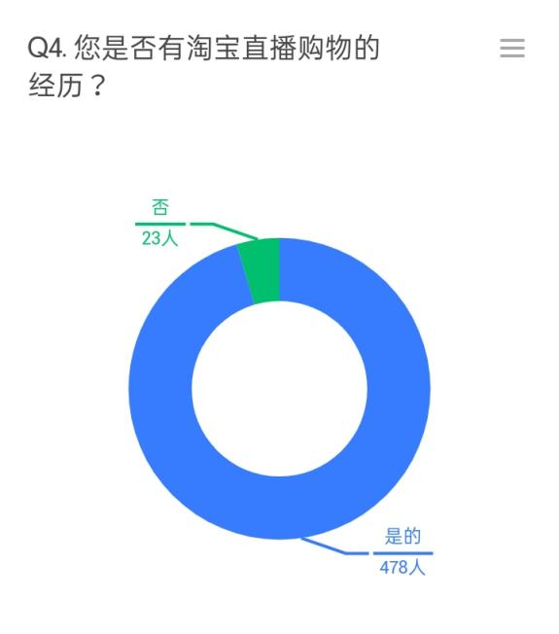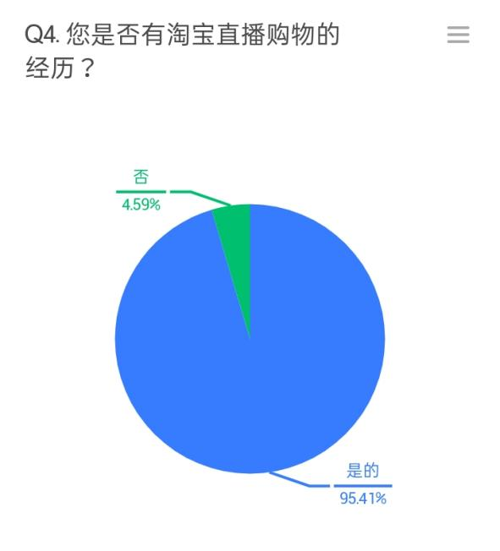

Figure 7. Question 4

The absolute majority or the respondents have had experience using Taobao Live.

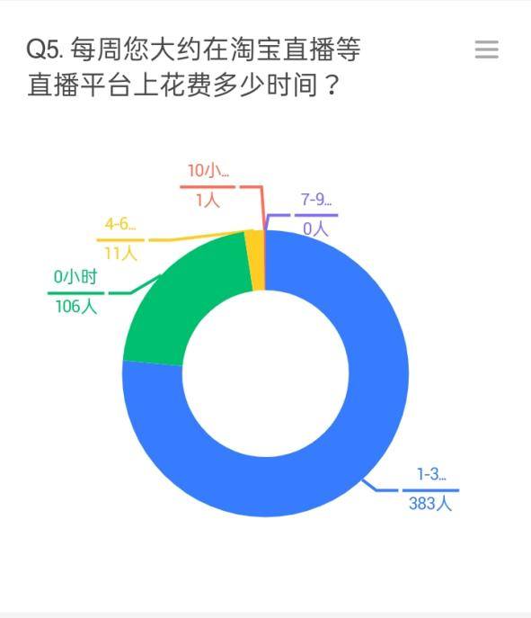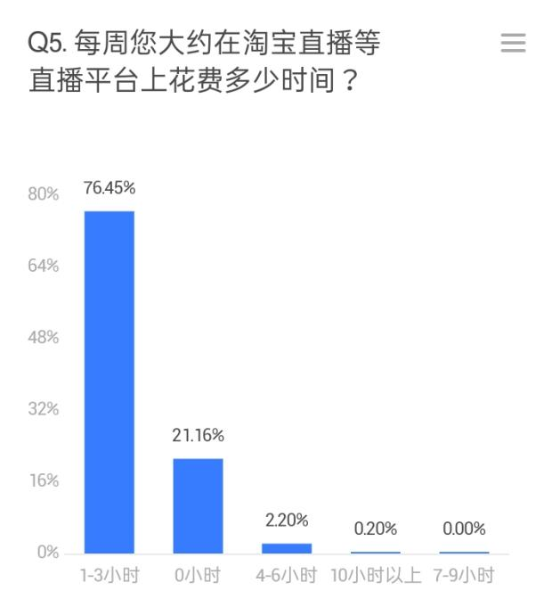

Figure 8. Question 5

76.45% reported spending between 1-3 hours a week on live streaming platforms. 21% responded with 0, which can indicate no prior experience with live streaming platforms or less than one hour of time spent on the platforms per week.

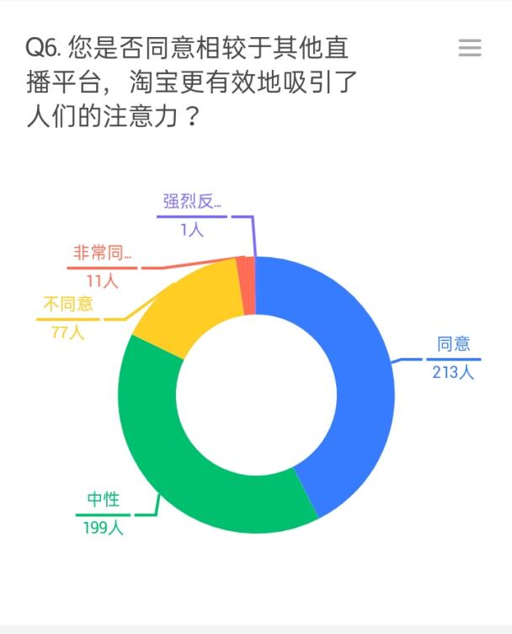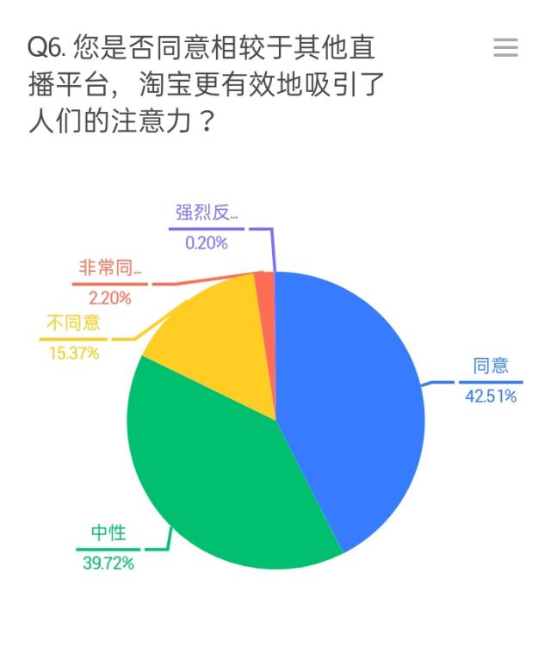

Figure 9. Question 6

42% of people agreed and 2% strongly agreed that live streaming has provided a better environment for drawing people's attention, while 39% responded with ‘neutral’.

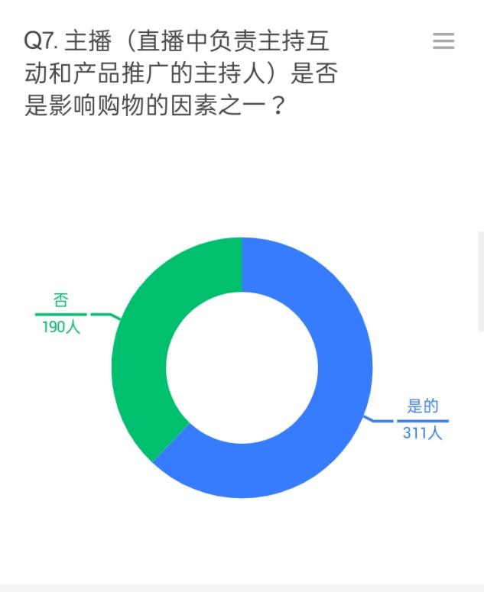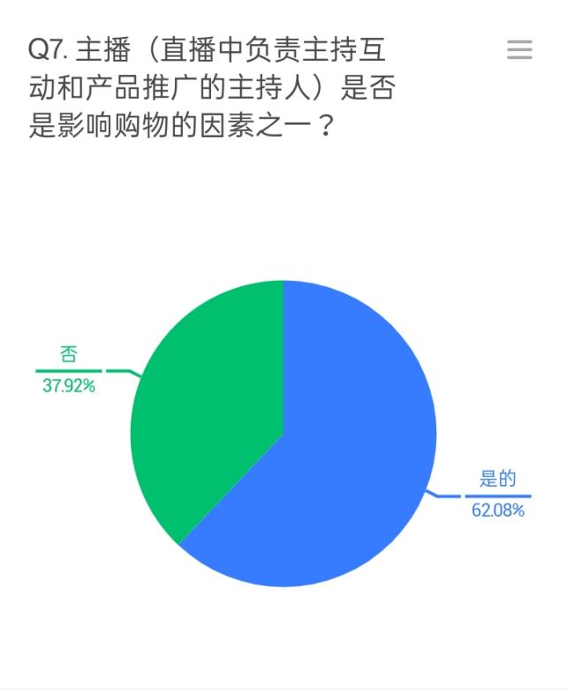

Figure 10. Question 7

More than a half (62%) stated that the presence of the live streamer is an important factor in influencing buying behavior.

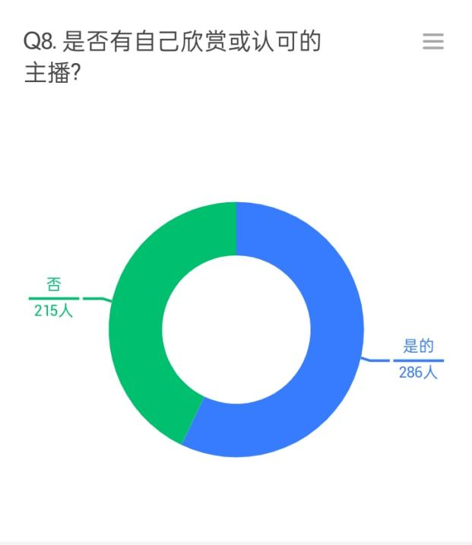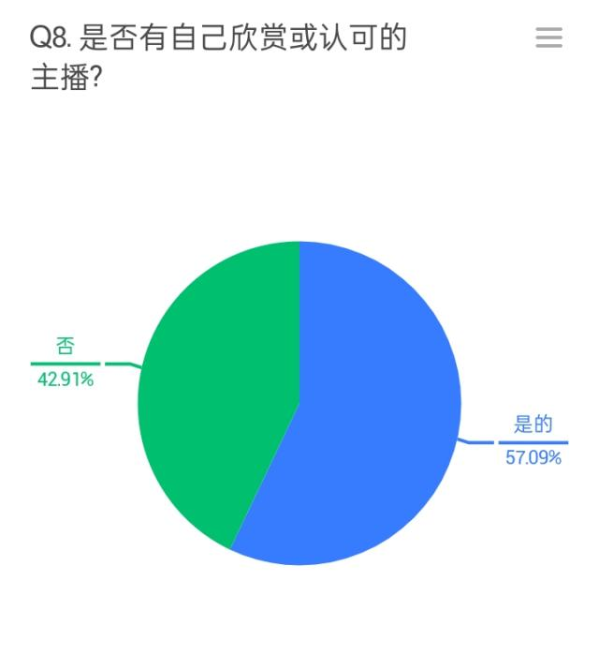

Figure 11. Question 8

Slightly more than a half (57%) reported having a favorite live streamer that they follow.

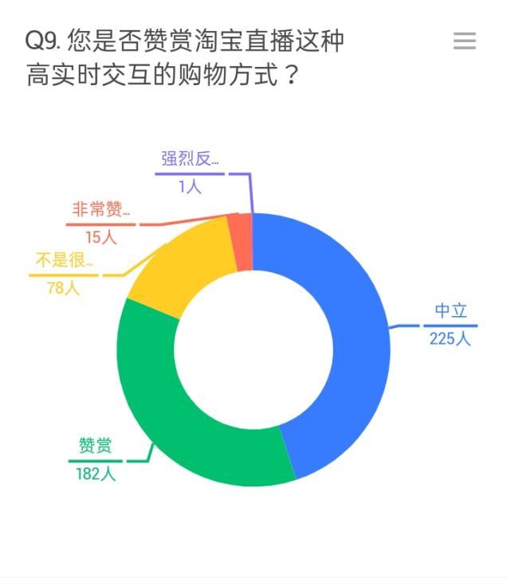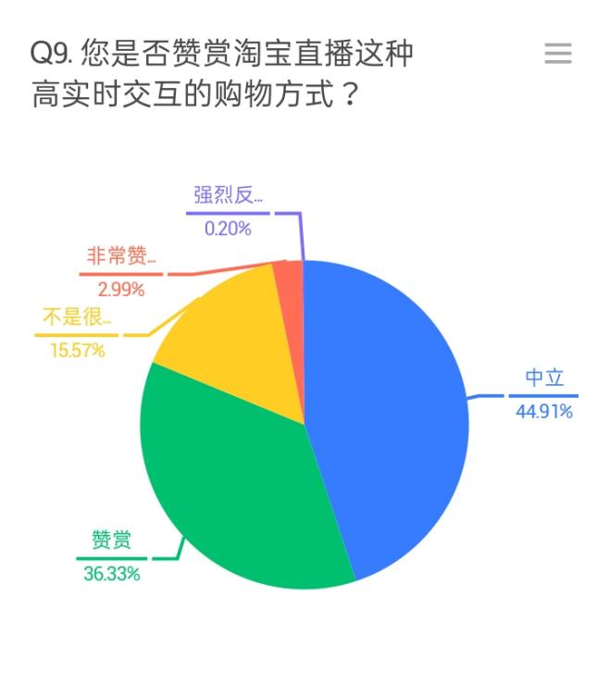

Figure 12. Question 9

44% agreed and about 3% strongly agreed that they appreciate Taobao as a highly interactive way of shopping, while 36% responded with ‘neutral’.

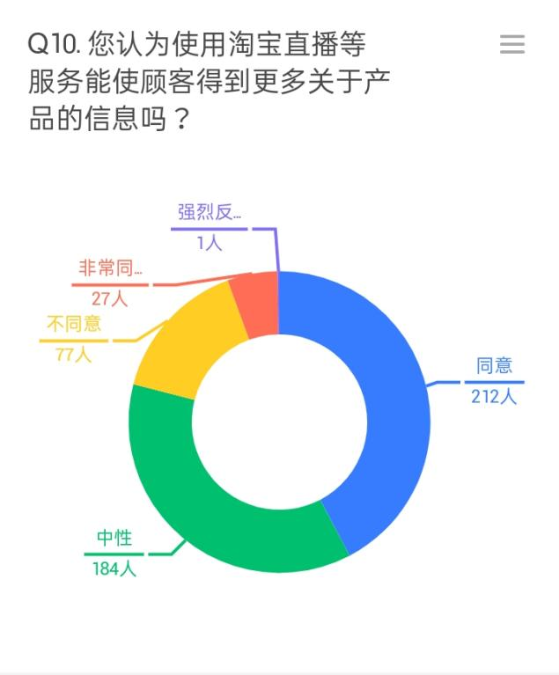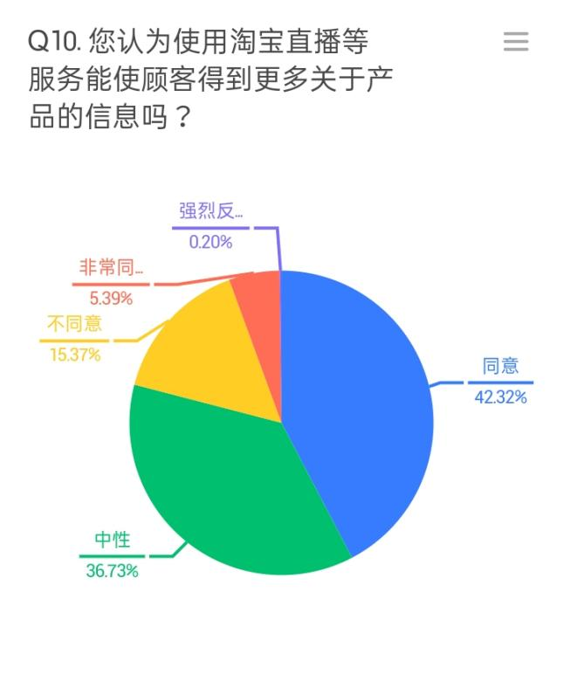

Figure 13. Question 10

42% agreed and 5% strongly agreed that through live streaming they can receive more information about the product than through any other medium. 36% responded with ‘neutral’.

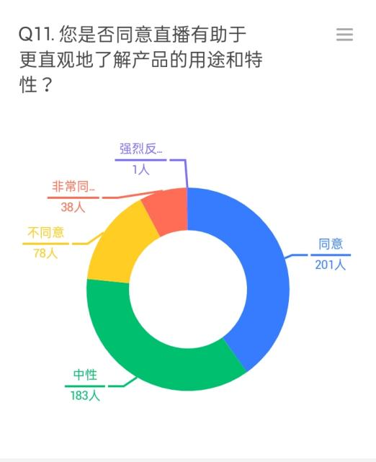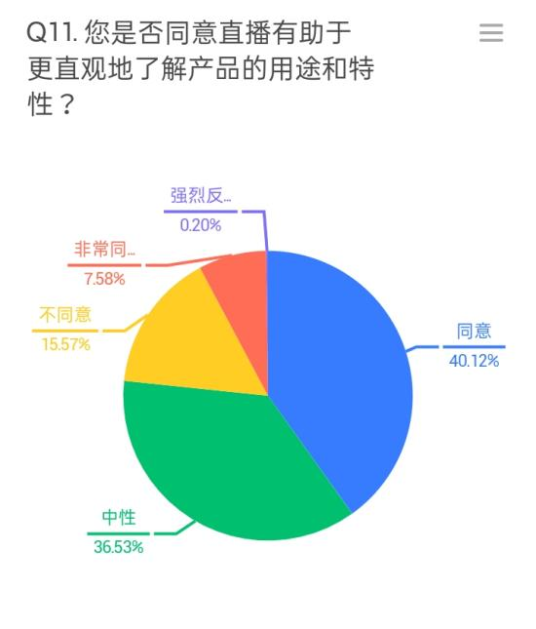

Figure 14. Question 11

40% agreed and 7% strongly agreed that live streaming is informative in terms of product use and features. 36% responded with ‘neutral’.

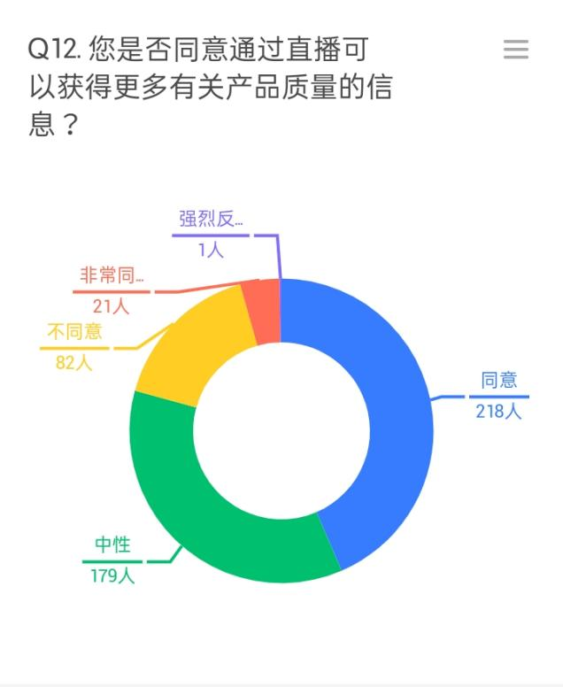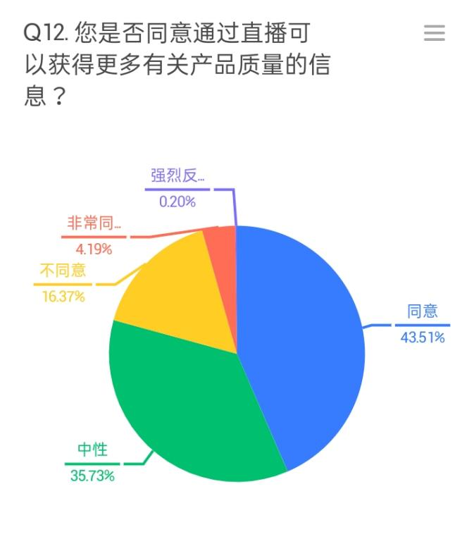

Figure 15. Question 12

43% agreed and 4% strongly agreed that live streaming is informative in terms of product quality. 35% responded with ‘neutral’.

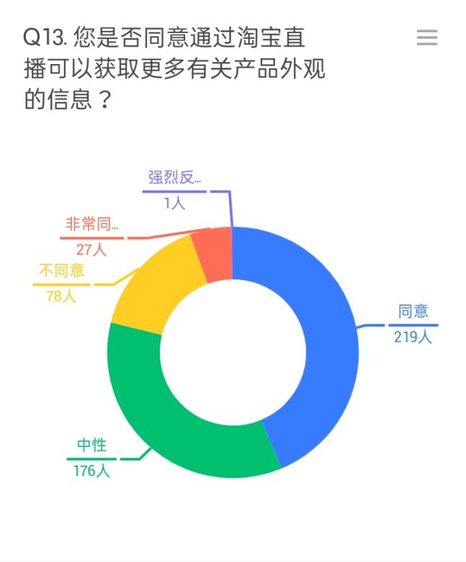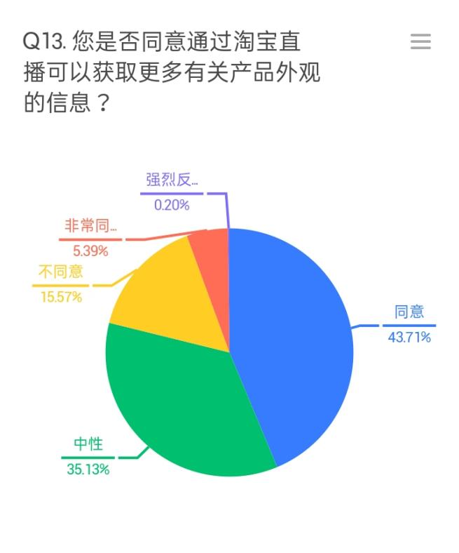

Figure 16. Question 13

43% agreed and 5% strongly agreed that live streaming is informative in terms of product appearance. 35% responded with ‘neutral’.

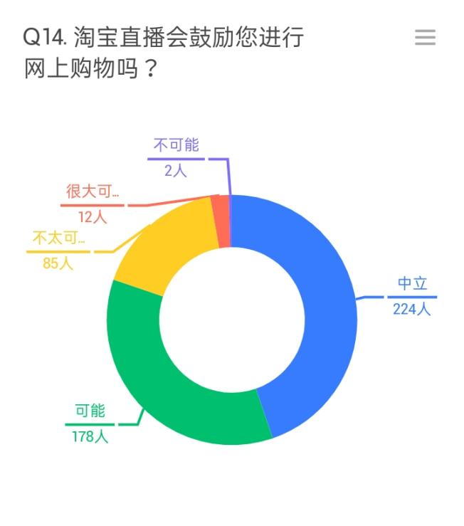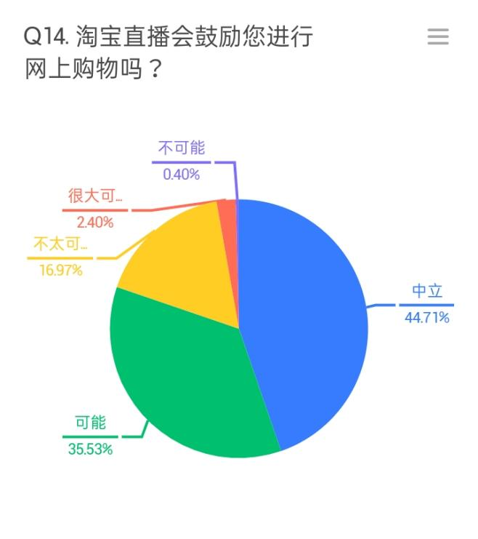

Figure 17. Question 14

And finally, 44% reported that Taobao Live is likely to influence them to do online shopping. 2% responded with “very likely” and 35% responded with ‘neutral’.

THE REGRESSION TABLE

|  |  |  |  |  |  |
| --- | --- | --- | --- | --- | --- |
|  | (1) | (2) | (3) | (4) | (5) |
| VARIABLES | influence | influence | influence | influence | influence |
|  |  |  |  |  |  |
| information | 0.529*** |  |  |  | 0.168*** |
|  | (15.35) |  |  |  | (3.38) |
| attraction |  | 0.589*** |  |  | 0.233*** |
|  |  | (15.93) |  |  | (4.35) |
| interactivity |  |  | 0.610*** |  | 0.317*** |
|  |  |  | (16.28) |  | (6.41) |
| loyalty |  |  |  | 0.417*** | 0.091 |
|  |  |  |  | (6.44) | (1.64) |
| age | -0.226*** | -0.219*** | -0.189*** | -0.456*** | -0.113*** |
|  | (-5.44) | (-5.33) | (-4.55) | (-10.32) | (-2.85) |
| online time | 0.041 | 0.040* | 0.049** | 0.060** | 0.052** |
|  | (1.64) | (1.65) | (2.01) | (2.04) | (2.28) |
| gender | -0.056 | -0.034 | 0.018 | 0.127* | 0.059 |
|  | (-1.23) | (-0.76) | (0.41) | (1.96) | (1.14) |
| experience | 0.059 | 0.027 | 0.096 | -0.095 | 0.018 |
|  | (0.57) | (0.26) | (0.94) | (-0.76) | (0.18) |
| use time | 0.202*** | 0.165** | 0.160** | 0.526*** | 0.115* |
|  | (3.08) | (2.53) | (2.47) | (7.11) | (1.83) |
| Constant | 1.532*** | 1.431*** | 1.189*** | 3.100*** | 0.659*** |
|  | (6.26) | (5.88) | (4.77) | (12.32) | (2.73) |
|  |  |  |  |  |  |
| Observations | 501 | 501 | 501 | 501 | 501 |
| R-squared | 0.674 | 0.682 | 0.687 | 0.556 | 0.728 |
| F test | 0 | 0 | 0 | 0 | 0 |
| r2_a | 0.670 | 0.678 | 0.683 | 0.551 | 0.723 |
| F | 170.4 | 176.6 | 180.6 | 103.1 | 146.0 |

Figure 18. Regression Table

In the regression table, the Y exploratory variable is named ‘influence’ and refers to the perceived degree to which people will be influenced to participate in the online shopping activities after attending a life stream. The data is derived from the answers on question 14 of the survey.

The X control variables are named as following:

‘information’ for the comprehensive perception of product information abundance delivered through live streaming (questions 10-13);

‘attraction’ for the perceived degree to which live streaming is more effective at drawing people’s attention towards the products (question 6);

‘interactivity’ for the extent to which the respondents appreciate the live streaming platform as highly interactive (question 9);

‘loyalty’ for how important the participants consider the live streamer to be in influencing buying behavior and whether or not they have one they follow (questions 7-8);

‘age’ for the respondents’ age group (question 2);

‘online_time’ for the average time consumers spend online outside of work (question 3);

‘gender’ for the participant’s gender (question 1);

‘experience’ for whether or not participants have experience using the live streaming platform of Taobao Live in particular (question 4);

‘use_time’ for the average time people spend on Taobao Live every week.

SUMMARY

### **5.2.1 H1. Taobao Live successfully handles complex buying behavior because its environment allows users to familiarize with the products in more detail.**

From the survey answers on questions 10-14 we make a conclusion about the hypothesis H1, and its components H1a, H1b, H1c, and H1d. Apparently, the majority of respondents either stayed neutral or agreed with the statements that from Taobao Live they can receive more detailed information on products, product use and features, product quality and product appearance, while a significantly smaller number of respondents disagreed. The ratios of positive answers to negative are as follows:

### **5.2.2 H2. Taobao Live successfully handles dissonance reducing buying behavior by drawing user's attention to the products, therefore providing bigger visibility and perceived availability for consumers.**

Considering the question 6 we can make a conclusion about the validity of the H2 hypothesis. It seems like the biggest part of the respondents agreed that Taobao Live does a better job at drawing attention of the users to the products than other live streaming platforms.

### **5.2.3 H3. Taobao Live is influencing buying behavior, because it provides a highly interactive platform both among users and between users and businesses.**

According to the questions 7-9 we can judge whether or not the H3 hypothesis is true.

Again, the majority of participants gave positive answers to all the three questions about live streamers and platform interactivity.

### **5.2.4 H4. Taobao Live influences buying behavior because it provides a platform, where consumers can be highly engaged with the brands, and form brand loyalty.**

The confirmation of the fourth hypothesis can be found in multiple questions from 3-6 to questions 7-9, since the topic of interactivity from the previous hypothesis is closely connected with the topic of consumer engagement. The results of the survey confirm that the hypothesis is also applicable to Taobao Live.